Mathematics Project

Topic: Height & Distance

Height & Distance: Application in Trigonometry

* How Heights & Distances are extensively used in real-life

**Introduction**: Let’s see a practical example where we would try to find out the need of “Height and Distance” theory in mathematics.

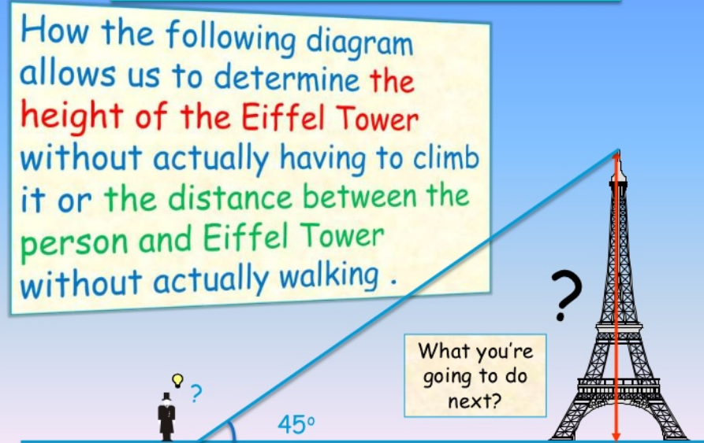

In the above situation, the distance or the heights can be founded by using mathematical techniques, which comes under a branch of ‘trigonometry’. The word ‘trigonometry’ is derived from the **Greek** word ‘**tri’** meaning three, ‘**gon’** meaning sides and ‘**metron’** meaning measures.

So three-sides-measures concept i.e. relationship between angles and sides of triangles can be applied in the above application to find the heights/distances of **objects.**

**Techniques followed:** Here are the three different techniques can be used to measure the height of the tower or the distance between the person and the tower

Technique1:

If the tower is sitting in the middle of a flat field, probably the easiest technique is to use its shadow on a sunny day. Take a broomstick, a hammer and a measuring tape with you. Pound the broomstick into the ground a few inches so it stands up on its own. If you are patient, you can wait until the length of the broomstick's shadow is equal to the length of the visible broomstick and then go measure the length of the tower's shadow. The length of the shadow tells you the height of the tower directly.

Technique2:

you need a drinking straw, a protractor, some scotch tape and a measuring tape. Tape the drinking straw to the protractor at the 45-degree angle mark. Hold the protractor with its flat side level with the horizon and then sight through the drinking straw. Walk a distance away from the tower until you can see the top of the tower through the straw. Since you are sighting the top of the tower at a 45-degree angle, your distance from the tower is equal to the height of the tower. Measure your distance from the tower and you know its height.

Technnique3:

you need a protractor, drinking straw, tape measure and a calculator that will handle trigonometric functions. Stand somewhere where you can easily measure your distance to the tower. Sight through the drinking straw and find the top of the tower, and then measure the angle between the straw and the horizon using the protractor. Let's say the angle is 55 degrees, and the distance to the base is 200 feet. The equation to use is:

Height of tower = distance from tower * tan(angle)

So,

Height of tower = 200 feet * tan(55 degrees) = 200 feet * 1.43 = 286 feet

Historical Example:

Following are some of the real-life examples where the ‘height and distance’ theory has been extensively used

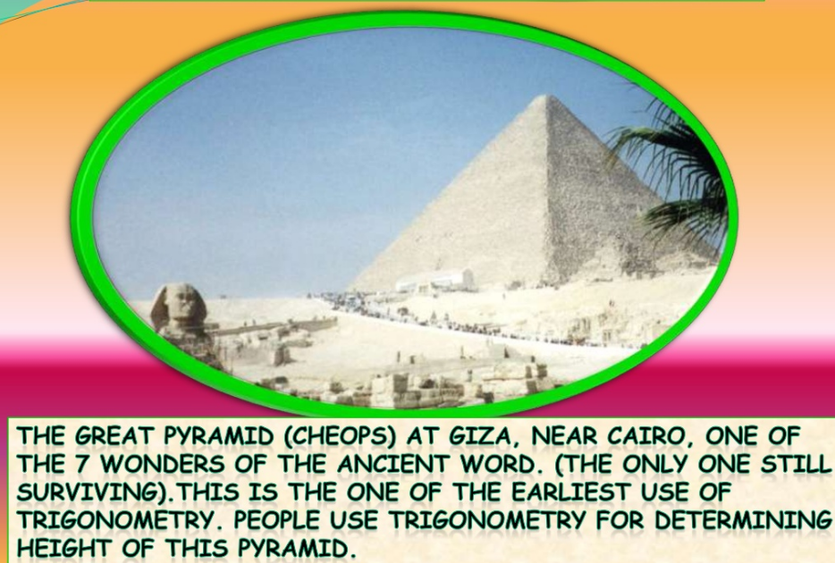

The relationship between the heights of objects and the length of their shadow’s theorem is used to calculate the height for them.

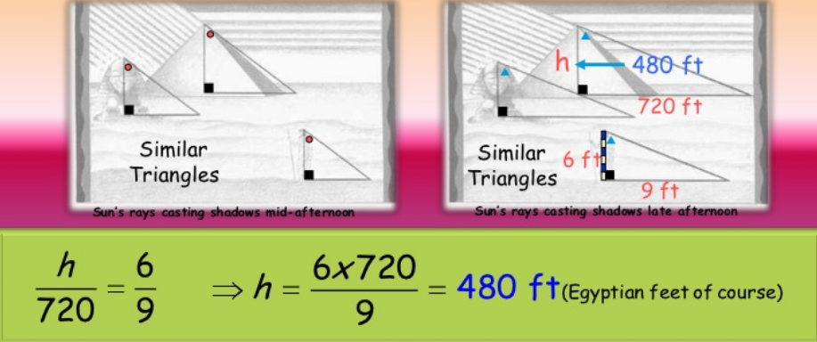

Ancient applications where this concept of trigonometry has been used –

* Finding the height of a mountain and hill

To calculate the elevation of a mountain, scientists would measure the distance between two points on the ground and then measure the angles between the top of the mountain and each point. "If you have two angles, you know the third, because the sum of the angles is 180 [degrees]. With two angles and one side of a triangle, trigonometry reveals the lengths of the other sides, and thereby, the height of the triangle (the mountain).

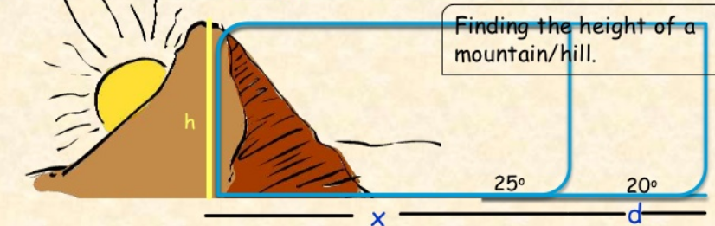

* Sundials- Architects use this concept to calculate structural load, roof slopes, ground surfaces and many other aspects, including sun shading and light angles.

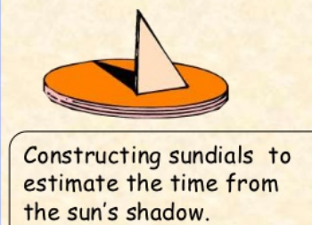

* Astronomy-

In 2001, a group of European astronomers did an experiment that started in 1997 about the distance of Venus from the Sun. Venus was about 105,000,000kilometers away from the Sun.

